Book Search – Search Limits
What do each of those things at the bottom of the Book Search screen mean - and how do you use them effectively?
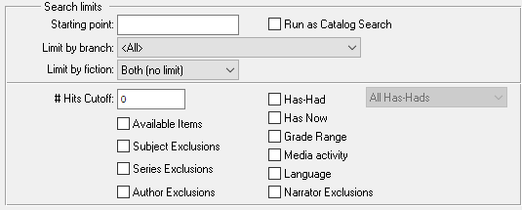
Starting point | The results you get should start at a particular point in the catalog and go higher.  Examples: DB would tell the system to start with the DB titles.  DB07 would look at titles DB070000 and higher
Run as Catalog Search | The search results will not be checked against the patron record, so there will be no indications for things like Has-Had or Language or Grade level, resulting in a faster search but less information.
Limit by branch | The selected branch should be able to assign the results. In these days of sharing of collections, those books may not be actually in that branch, but are available to patrons of that branch.
Limit by fiction | The system will check the results, looking at the fiction checkbox. If you wish to only get fiction, or only non-fiction, this is a useful setting.  Examples: A subject search for Cookbooks limited to fiction would help you find novels that include recipes
#Hits Cutoff | A number giving the maximum number of results you want to deal with. Be careful here, as the bigger the number, the longer you can theoretically wait for the results to be returned. A reasonable number is 25 - 50. If you set the cutoff to zero, you get all the results – be careful with this when you search for something like Mystery or Western!

When you search, the results are coded in comparison to your patron's record. For example, if the title is on the patron's Has-Had list, you'll see an H in the search results. This is handy to know when you're on the phone with a patron and searching for an author.
If you would prefer not to have the entries that have codes displayed at all, you can place a checkmark in the corresponding box at the bottom of the screen to exclude those titles from your search.
Available Items | Don't show titles that are not available. (code 0)
Subject Exclusions | Don't show titles that include a subject the patron has an exclusion against. (code PS)
Series Exclusions | Don't show titles in series excluded by the patron. (no code displayed)
Has-Had | Don't show titles the patron has had before. The date of the Has-Had will be displayed at the bottom of the screen for any title you select. (code H)  Note: you can select a time period for this exclusion, so you can remove titles they've had recently, but allow the older titles to return to the results.
Has Now | Don't show titles the patron has OUT right now. (code N)
Grade Range | Don't show titles that are not at the patron's reading level. (code G)
Media Activity | Don't show titles in a format the patron isn't subscribed to. (code M)
Language | Don't show titles in a language not on the patron's record. (code L)
Narrator exclusion | Don't show titles where the narrator is on the patron's exclusion list.  (code PN)

