Machine Count by Status Report

Process overview
As announced on KLASusers.com and by email, we have created a Machine Count by Status report to provide NLS with the machine data they are requesting. Please see the How-To document for instructions on running the report.
This follow-up contains more detailed information on addressing the report output and submitting your totals to NLS. As always, please contact us if you have questions or need help.
Thank you again for your assistance!

Outline
- Transfer Out Status
- Example Report At-a-Glance
- Status by Status Breakdown

Transfer Out Status
Since you will only be reporting the totals to NLS instead of submitting the full details of the report, please be sure that you do not count TFO / Transfer Out machines in your totals!
KLAS still counts transferred machines as PIMMS' On Loan, because the last time KLAS saw the machine, it was On Loan. After that, PIMMS knows which system to check for the machine's status; the KLAS status becomes redundant.

Example Report At-a-Glance
This sample report illustrates how to total the data from the report and points out some common data issues. For more detail on each section, see the Status by Status breakdown.
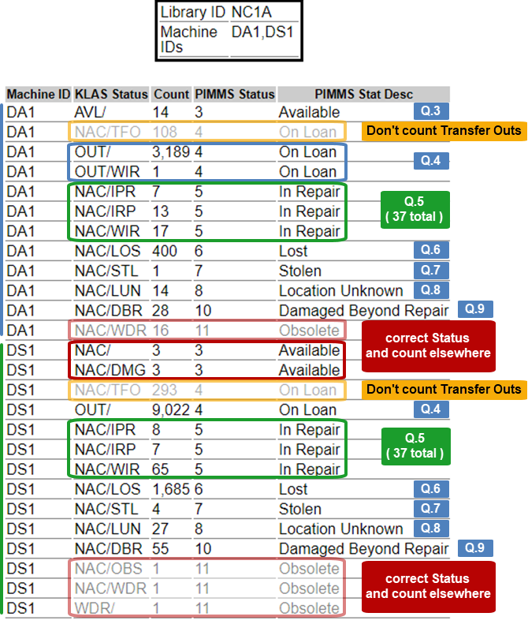

Status by Status

PIMMS Status 3 – Available
Available is pretty straightforward. You should only have one line for this status for each machine type, with the KLAS Status of AVL / [none].
If you have any other KLAS Statuses with a PIMMS Status of 3 - Available, they are almost certainly incorrect.
These lines need to be cleaned up. NAC (Not Available) should always have a disposition to indicate why it is not available for circulation. Meanwhile, DMG (Damaged) machines should always be either “In Repair” (NAC / IPR, IRP, or WIR) or “Damaged Beyond Repair” (NAC / DBR).
You may need to look at the history for these machines to determine their proper status. Once you know what their status should be, correct it in KLAS and include them in the correct count.
For Question 3 of the survey, we would report that 14 DA1s are available In Stock.

PIMMS Status 4 – On Loan
These are the machines currently on loan to patrons or institutions, so the KLAS Status should be OUT / [none].
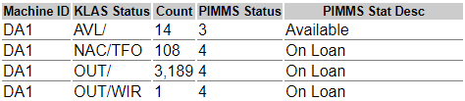
Remember not to include NAC / TFO in your count. These transferred machines will be reported by their current responsible libraries.
If there are machines with a disposition, such as OUT / WIR in our example, it is probably just “left over” from a previous NAC status. Go ahead and count them with your On Loan materials, but we recommend that you also correct the status to avoid confusion.
For Question 4, we would report that 3,190 DA1s are On Loan.

PIMMS Status 5 – In Repair
This PIMMS Status covers these specific dispositions: IPR (In Processing), IRP (In RePair), WIR (Waiting In Repair), and WFT (Waiting For Repair). The KLAS Status should always be NAC.
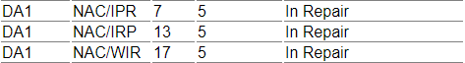
For Question 5, we would report that 37 DA1s are In Repair.

PIMMS Status 6 through 10
These statuses correspond directly with KLAS dispositions; you should only have one line for each.
- 6 - Lost is NAC / LOS
- 7 - Stolen is NAC / STL
- 8 - Location Unknown is NAC / LUN
- 10 - Damaged Beyond Repair is NAC / DBR
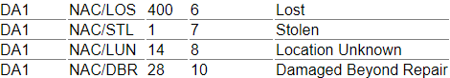
We would enter these numbers for Questions 6 - 9.

Question 10
This question allows you to report any other machines that have not yet been counted.
For this question, report the total of:
- Any digital machines that are not inventoried in KLAS.
- Any machines in a status not included above.

