NGW1: Fact-filled, fast-paced magazine created especially for ages 6 and up.
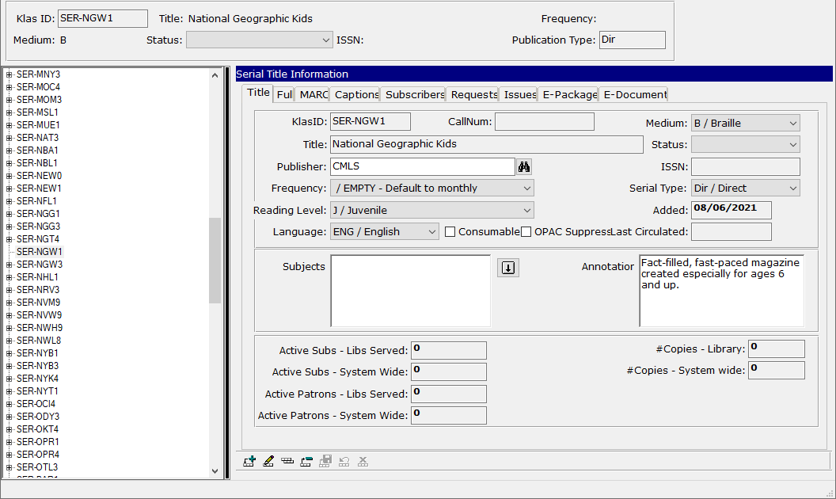
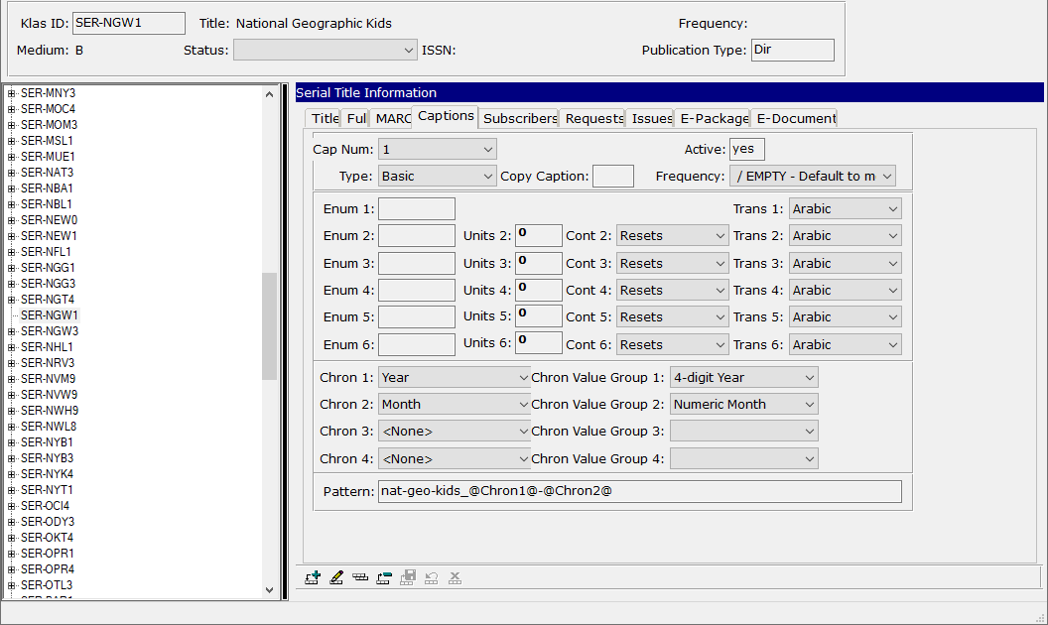
SPK1: Sports news and articles for ages 8 to 13; features sports personalities, events, and sports cards; youth who are excelling in sports; regular column by youth discussing a controversial sports-related issue.
