Keyboard Commands

Process overview
It is possible to use KLAS more quickly and accurately by making use of keyboard commands and shortcuts. This guide is intended to help get started using the Patron Module without needing your mouse by practicing three common tasks. We recommend that you practice without using the mouse at all, but once you begin to feel more comfortable using the keyboard commands, you can use whatever combination of keyboard and mouse is fastest and most comfortable for you.
Check out the “QuickRef-Keyboard” document for a cheat sheet of keyboard commands and shortcuts; it’s a great reference to keep on hand as you are learning, and as a quick reminder later on.
For screen-reader users, the KLAS AT Reference - Keys & Screens document includes more information on screen layouts and context.

Outline and commands used
- Find a Patron
  - Find Record - Ctrl + F
  - Move to Next Object - Tab
  - Move to Previous Object - Shift + Tab
  - Add Super Tab - F11
  - Next Super Tab - F12
- Add Quick Preferences
  - Jump to tab - Alt or Ctrl + #
  - Quick Preferences - Ctrl + Alt + N
  - Save - Alt + S
  - Okay (dismiss alert) - Alt + O
  - Close Window - Alt + X or Alt + F4
- Book Search
  - Book Search - Ctrl + B
  - Run Search - Alt + S or Enter
  - Select / Deselect Search Results - Space Bar
  - Assign - Ctrl + G
  - Reserve - Alt + V
  - Request - Alt + R
- Bonus: Using Menus

Task One – Find a Patron
One-time setup: Tab to (or click on) the first row of the browse table, then press F11 to create a Super Tab for this location.
This Super Tab location will remain in place unless it is manually removed.
- Anywhere in the Patron Module, press Ctrl + F to open Find Patron.
- The cursor will default to the field designated by your library’s settings; if needed, press Tab to move to the last name field.
- Type in the first several letters of the last name, then press Tab.
Notice that the list of patron names is shortened to include only the names matching what you have entered so far.
- Type in the first letter of the first name, then press Tab.
- If the list is down to only one name, press Enter to open the record.
Otherwise, Super Tab to the browse table by pressing F12. The first row of the table will be selected, since that is the Super Tab location you set beforehand. To move down the list, use the Down Arrow key. When the row your patron is in is highlighted, press Enter to open the record.
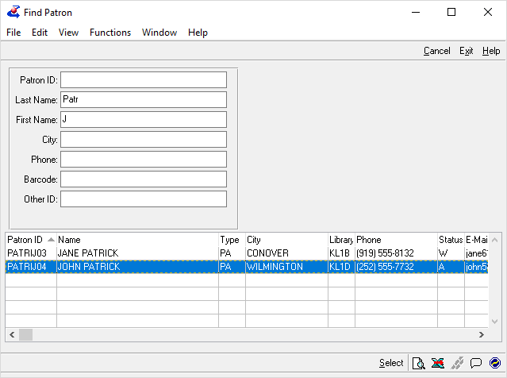
Ctrl + F
Tab
Tab
Super tab! F12
Down Arrow
Enter

Task Two – Add Quick Preferences
You can use Quick Preferences from anywhere in the Patron Module, but it’s helpful to move to the Preference tab so that you can tell what is already there. You can jump to any tab by using Alt (for the first 10 tabs) or Ctrl (for the rest), plus the tab number.
1 2 3 4 5 6 7 8 9 0 1 2 3 4
- Move to the Preference tab by pressing Alt+4.
- Use the Down Arrow to select “Subject” in the filter list, allowing you to review the subjects already on the patron’s record.
- Press Ctrl+Alt+N to open the Quick Preferences window.
- Tab to the entry field and enter the desired subject codes. Use an exclamation point to designate any code as an exclusion.
- Press Alt+S to Save the entered preferences.
- A window will pop-up to alert you to any errors or to confirm that all codes were saved; press Alt+O (for Okay) to dismiss the alert.
- The Quick Preferences window stays open so that you can make any corrections or add more subject codes. When you are finished with it, press Alt+X or Alt+F4 to close it.
Alt + 4
Down Arrow
Ctrl + Alt + N
Tab
Alt + S
Alt + X

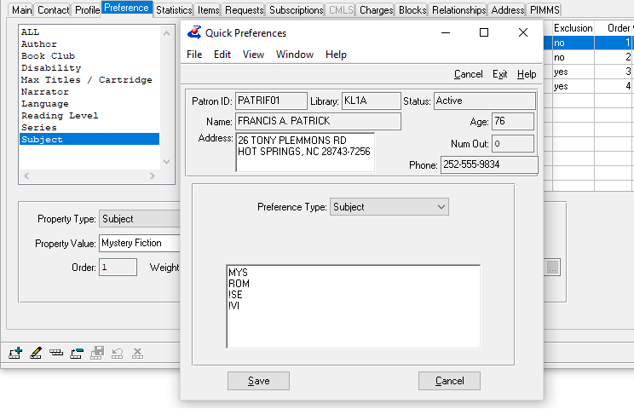

Task Three – Book Search
One-time setup: Tab to (or click on) the first field in each section, then press F11 to create a Super Tab for that location.
When you open the book search, your cursor will default to the first Super Tab, so make sure to set the first field (or your desired starting place) as the first Super Tab.
- Anywhere in the Patron Module, press Ctrl + B to open Book Search.
- Press Tab to move between fields to set your search criteria. Use F12 to Super Tab to the section you need.
- Use the Space Bar to Check or Un-check boxes for exclusions.
- Press Alt + S or Enter to run the search.
- Use the Up and Down Arrow Keys to move between results and press the Space Bar to select or deselect the active row.
  - Ctrl + G will Assign the selected titles.
  - Alt + V will Reserve the selected titles.
  - Alt + R will Request the selected titles.
- When you are finished, press Alt + X or Alt + F4 to close the results, and again to close the search window.
Ctrl + B
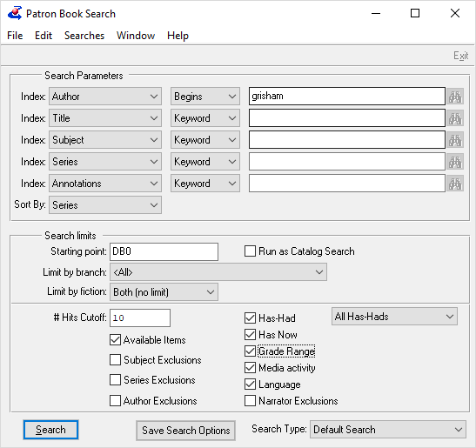
Recommended
Super Tab locations are outlined.
Super tab! F12
Tab
Tab
Alt + S

Bonus: Using Menus
Press and release the Alt key, then press the underlined letter to open any menu. You can then use the Up and Down Arrow keys to move through the list, or you can press any underlined letter to jump to that menu option.
For example, to open Labels, press Alt, then U (to open the Functions menu), then L for labels.
