How to find Records
with Missing Information

Process overview
This is a method to locate records that do not include a specific piece of information. Computers are very good at finding records that have certain information... and very inefficient at looking for the lack of information.
The easier way to go about it is to define two lists—a set of records that you are curious about, and a list of records that do have the criteria you think may be missing. Then, compare the two to find out which records are in the first list but not the second.
For example, this can be used to find catalog records with a certain narrator which are not marked as having a foreign accent. You could also find catalog records with “contains some strong language” in the annotation, but not the matching subject. Any time you are looking for information that isn’t there, give this method a shot!
- Export query or book search results to define your dataset.
(Ex: books narrated by James Macpherson)
- Export query or book search results that have the information you are checking.
(Ex: books with the subject Foreign Accent)
- Create a combined spreadsheet.
  - Copy the KLAS IDs from the first export into Column A.
  - Copy the KLAS IDs from the second export into Column B.
- Enter the following formula into Column C and duplicate it to each line.
  - =MATCH(A2,B:B,0)
- Sort by Column C to group “#N/A” results.
These are lines where the ID in Column A is not found in Column B—in other words, the KLAS ID in Column A of that row does not include the information you searched for.
- Copy that section of Column A to a notepad file to create and import a query set of the Records that need attention.

Step One – Export your dataset
This is the chunk of your catalog or patron set that you want to check for missing information. You can use query or book search; however you want to define the set of data to check is fine.
- For our example, we’ll do a book search for Narrator : Equals : Macpherson, James. I’ll also limit the search to DB, since I’m not interested in going back to fix RCs.
- From the results, click the Export to Excel icon. Make sure the Maximum is set large enough to include all of your hits.
- Leave the Excel sheet open in the background and return to KLAS.

Step Two – Export the information to check against
This is a list of the records that contain the information you think might be missing. You will use this list of records that do to find out which records do not. Again, you can use either query or book search.
- For our example, we’ll do a book search for Subject Code : Equals : FA (the local subject code for Foreign Accent).
Because we’re only concerned (for now) with DBs narrated by James Macpherson, we can leave those restrictions in place to help the search run faster, but that isn’t required! So long as everything from your first list is checked for the information in question, the end results will be the same either way.
- From the results, click the Export to Excel icon. Make sure the Maximum is set large enough to include all of your hits.

Step Three – Create a combined spreadsheet
- Open a new spreadsheet.
- Go back to the first set of data that you exported, and click the column heading letter (most likely A) to select the entire column of KLAS IDs. Copy them using Ctrl + C or the Copy button.
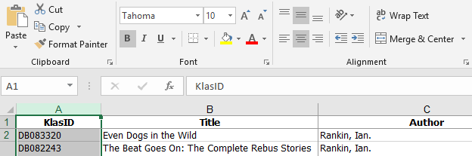
- Paste the information into Column A of your new spreadsheet using Ctrl + V or the Paste button.
- Go to the second set of data that you exported, and copy the entire column of KLAS IDs.
- Paste the information into Column B of your new spreadsheet. Once you have both lists in the combined spreadsheet, you can close the other spreadsheets.

Step Four – Enter a formula to compare the lists
- In the first row of Column C, enter this formula: =MATCH(A2,B:B,0)
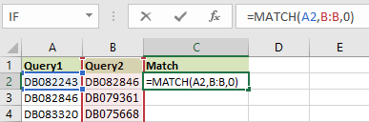
The formula checks to see if the value in Column A of that row matches anything in Column B.
- Copy the formula down the column until you get to the last row of Column A.
An easy way to do this is to click and hold the square at the bottom right of the cell and drag it down.

Step Five – Sort the Results
The formula will display either the Row Number where it found a match for the ID in Column A, or it will display #N/A, signaling that the data was not found anywhere in Column B.
These N/A results are the records that are missing information. It is easiest to work with these records to correct them if you sort the spreadsheet to group the N/A results together.
- Select Column C.
- Click the Sort & Filter icon, then select Sort Largest to Smallest.
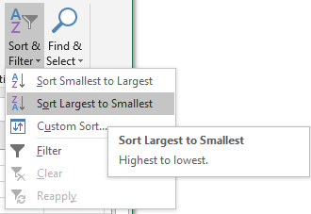
- Excel will open a Sort Warning window, asking whether it should also sort the rest of the columns. Make sure “Expand the selection” is active and click Sort.
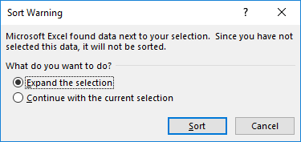
- The #N/A results should all be grouped at the top of the list.

Step Six – Create and Import a Query Set of results
You can look up the records with missing information one at a time. However, if there are more than a few, it will be quickest to import a query set and use the VCR buttons to move quickly between them.
- Copy the KLAS IDs in Column A that have a N/A result in Column C.
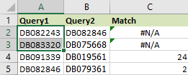
- Open a blank Notepad file and Paste the list of KLAS IDs.
- Save the file somewhere you can find it again, such as your desktop.
- In KLAS, use the Tools menu to select Import Query Set.
- Browse to select your Notepad file, then click Ok. The first record will open.
- Update and Save the record as needed to add the missing information, then use the VCR buttons to move to the next record.

