How to Change Font Size

Process overview
The KLAS client is built onto a fixed template, and it is normally only possible to change the size by adjusting the resolution or display settings in Windows. However, for users who require larger and/or bolder text, it is possible to make these modifications to the klas.ini file.
Before making these modifications, please note the potential complications or issues:
- Font customizations are workstation-based instead of user-based. This means that everyone using a certain computer will have the same settings and that the customizations will not be present if the intended user logs into a different workstation.
- Customizations will be reset the next time support files are run on the workstation (such as when applying a minor update) and must be backed up.
- The file to be modified is Version-specific and changes will need to be redone after upgrading to a new version.
- If fonts are made too large or otherwise not selected carefully, labels may appear cut-off and dates may become difficult to read.

To modify the klas.ini file to use custom font settings:
- Determine which fonts should be used. A proportional font, and a fixed pitch font will be needed.
- Check the shortcut target path to locate the .ini file used on that workstation.
- Open the .ini file for editing in notepad.
- Make necessary changes, then test several screens in KLAS to ensure text still “fits” in the fixed fields for labels and dates.
- Save a backup of the customized .ini file.

Additional notes:
- Fonts to Try
- What to Modify

Step One – Determine which font should be used
- Look in the users’ system folder to determine what fonts are available.
C:\Windows\fonts
- You must use a proportional font (such as MS SanSerif, Tahoma, or Verdana) and a fixed pitch font (such as Courier or Lucida Console). See Note I – Fonts to try for information on some fonts you might consider.

Step Two – Check the shortcut target path to locate the .ini file
- Right-click on the KLAS shortcut used by the person who needs customizations. Select Properties.
- Locate the -ini path specified at the end of the Target line. Look for -ini (underlined in the example text), then copy the file path after that indicator (as marked in red).
"C:\Program Files (x86)\OpenEdge\116\WebClient\bin\prowc.exe" -pf cfg\bphdemo\klas7.pf -ini cfg\76r2d\tklas7-64.ini
- The .ini file will be located at:
C:\klas7\WebClientApps\KLAS\[version]\[-ini path]
So for the previous example, the .ini file would be found at:
C:\klas7\WebClientApps\KLAS\76r2\cfg\76r2d\tklas7-64.ini

Step Three – Open the .ini file for editing
- If you have not made these customizations before, consider making a copy of the .ini file as a backup before editing, in case you want to undo all changes.
- Right-click on the .ini file to open the context menu and select the “open with” option.
- Select Notepad from the list of available programs.
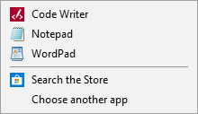
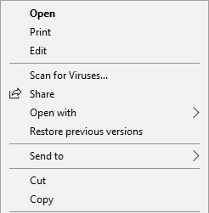

Step Four – Make necessary changes, then test
- Make the necessary changes to the file, referencing Note II – What to modify and the fonts selected in Step One.
- Open KLAS and log in. Because the changes are not user-based, you can use any account to log in; it does not need to be the intended users’.
- If the selected font is wider than the system allows, it may trigger error messages. However, even if no errors are triggered, make sure to test various screens to ensure that labels, dates, and other text are readable.
- The Catalogue module Title-Bib screen is a good first test, as it contains a large number of fields and field labels, shows the fixed font in the ReplaceCost field, and has date fields with pre-formatted forward slashes (Added and Modified).
- If the intended user expects to use a certain module or feature frequently (such as the Patron Module, Materials Requests, or a Circulation function), be sure to test those screens as well.

Step Five – Save a backup of the customized .ini file
- When you are satisfied that the changes meet the users’ needs and do not create any additional issues, save a copy of the modified file.
  - The backup file should be saved somewhere it can be easily located after each update or reinstallation.
  - In case of system failure, consider saving the backup file to an external or networked drive.
- Remember that version upgrades will require modifications to the new .ini file. To make these modifications easier, without needing to reference the code in the old .ini file, keep a record of the fonts and sizes used.

Note I – Fonts to Try

Proportional fonts for DefaultFont or Font4
Verdana | Designed to be readable at smaller sizes, large x-height, wider proportions, more space between letters; stock font from Microsoft.
Tahoma | Narrower body and tighter spacing than Verdana, stronger bold, designed for on screen use at size 8 or 10, doesn't work as well at size 9; stock font from Microsoft.
Segoe UI | Used by MS for onscreen display, optimized for use at size 8, 9, or 10. Has Bold and Semibold variants, has glyphs for a wide range of languages.
Helvetica | Traditional sans-serif print font, tight letter spacing, dense compact format.
Arial,  MS Sans Serif | Variations on Helvetica more frequently available on windows systems due to licensing.
Gotham Rounded | More rounded and geometric, has special variations for on-screen use, may not be as commonly available.
Lucida Sans | Designed for legibility in blocks of text & on-screen displays; large number of variants and full character sets; widely available.
Calibri, Corbel | Sans serif fonts that are part of MS ClearType font collection, default usage in MS Word; line spacing for Calibri is more suited for blocks of text and the same font size will appear smaller than a font such as Verdana or Tahoma.
APHont | From APH, developed specifically to address common issues for low-vision readers, special download from APH.
Tiresias PCFont | From RNIB, developed for use in captions and subtitles in the UK, PCfont variation has fixed pitch for numbers.

Fixed pitch fonts for DefaultFixedFont and Font0
Courier New, Bold | Default fixed font in Windows, based on type writer, in regular/non-bold lines are very thin
Lucida Console | Sans serif fixed pitch font with tight line spacing; large x-height, default font for Notepad in windows.
Monaco | Sans serif fixed pitch font standard for Macintosh computers, narrower than other fixed fonts so can use the same size as the proportional. has distinctive letter forms for 0 (zero), 1 (one), | (vertical bar), I (uppercase i), and l (lowercase L)
Consolas | Fixed pitch font distributed as part of MS ClearType Compatibility package (Calibri, Cambria, etc.), distinctive 0 (zero), l (lowercase L) forms

Below is a screen shot of an FHD monitor (1920x1080) desktop with Catalog, MatRequests, and Patron-Items open using the following settings:
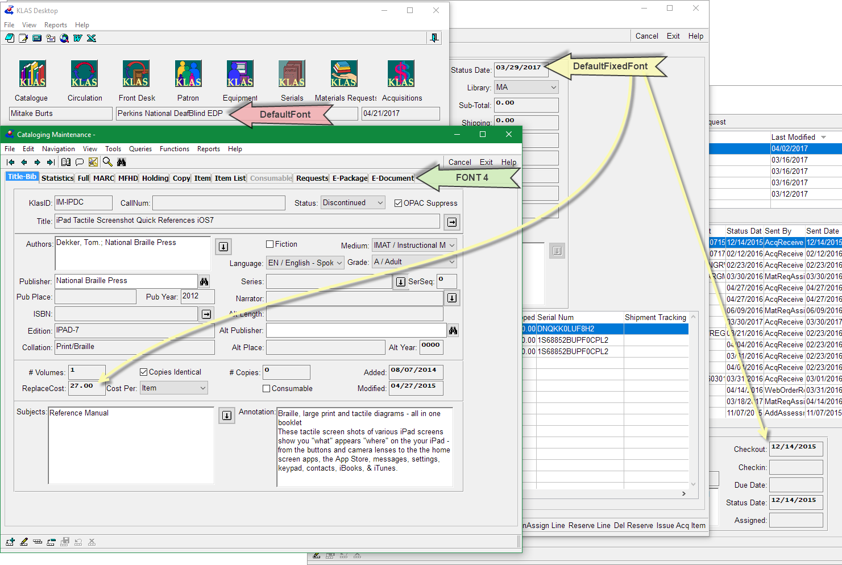
DefaultFont=MS Sans Serif, size=10
DefaultFixedFont=Lucida Console, size=8, bold
font4=Tahoma, size=9, bold

Screen shot of Equipment Screen using Segoe UI in the regular, semibold and bold variations.
DefaultFont=Segoe UI, size=9 | Segoe UI Semibold, size=9 | Segoe UI, size=9, bold
DefaultFixedFont=Monaco, size=9
font4=Verdana, size=10, bold
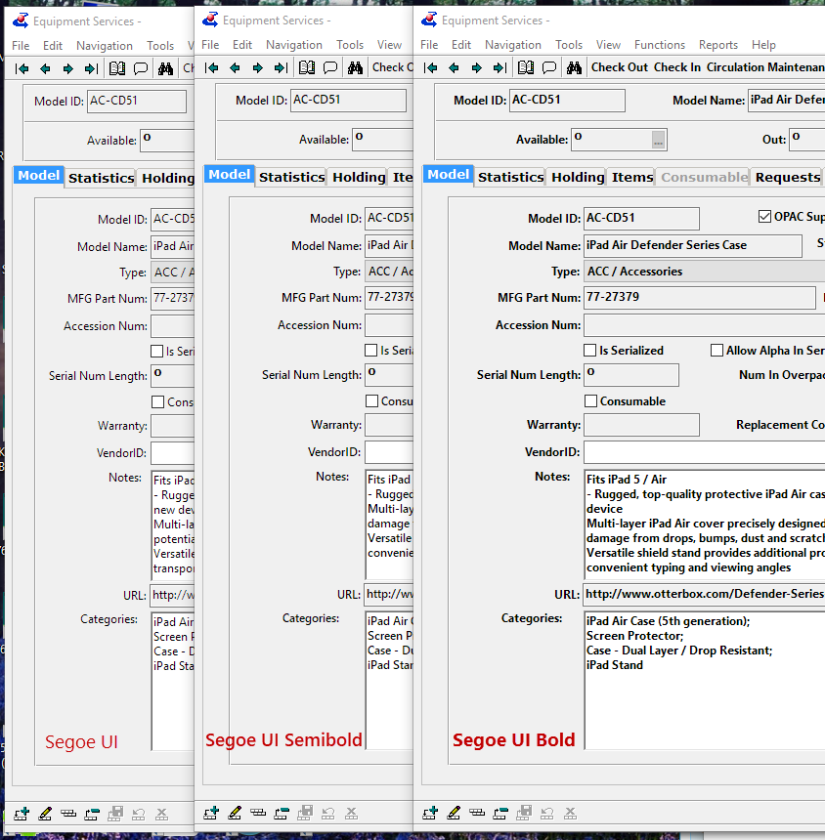

Note II – What to Modify
In the top section labeled "Startup"
DefaultFont sets the font for the bulk of the text in KLAS. DefaultFixedFont sets the font for items that use a fixed width font, predominately date & number fields.
[Startup]
V6Display=no
OldBrowseSelectionBar=Yes
DefaultFont=MS Sans Serif, size=8
DefaultFixedFont=Courier New, size=8
Use-3D-Size=Yes
PROPATH=r2b.pl,r2a.pl,.,src/dynamics,src,dynamics.pl,adm2.pl,ks.pl,cc.pl,pa.pl,ps.pl,ct.pl,eq.pl,sc.pl,aq.pl,mr.pl
Keep3DFillinBorder=Yes
UseRichEdit10=Yes
In the "fonts" section
Font4 is used by the folder tabs, Font0 is used by system messages like "Leaving Query" and "close this window and all of its children".
[fonts]
;******************************************************************************
; THE DEFINITION OF FONT 0 THROUGH 7 IS PRIVATE TO THE PROGRESS ADE.
; MODIFYING FONTS 0 THROUGH 7 MAY PREVENT THE PROGRESS ADE FROM RUNNING.
; The following fonts definitions correspond to the ADE standards.
; ? - DefaultFont from Startup Section
; 0 - DefaultFixedFont from Startup Section (1 char per PPU)
; 1 - Proportional System Font
; 2 - Editor Font for 4GL program entry
; 3 - TTY Simulator (should be fixed)
; 4 - Dynamically-sized widgets, eg status-line, selection-list
; 5 - Static widgets, eg. combo-boxes
; 6 - Dynamic, bold (TranMan2)
; 7 - Reserved
font0=Courier New, size=8
font1=MS Sans Serif, size=8
font2=Courier New, size=8
font3=Courier New, size=8
font4=MS Sans Serif, size=8
font5=MS Sans Serif, size=10
font6=MS Sans Serif, size=8, bold
font7=MS Sans Serif, size=8
font8=Arial Black, size=18

Suggested options
The settings to change are in the top section of the file called [Startup]:
DefaultFont=MS Sans Serif, size=8
DefaultFixedFont=Courier New, size=8
If you just need to make them bolder:
DefaultFont=MS Sans Serif, size=8, bold
DefaultFixedFont=Courier New, size=8, bold
An option for larger, bolder, and a common font variation:
DefaultFont=Verdana, size=10, bold
DefaultFixedFont=Lucida Console, size=8, bold /*gives the cleaner bolder dates, without making the dates so wide that they don't display in most boxes */

