KLAS UC 2025 Business Meeting Agenda
Driving Innovation & Inclusion in Libraries: Start Your Engines!
March 20, 2025
Indiana State Library, Indianapolis, Indiana

Call to Order
The business meeting of the 2025 KLAS Users’ Conference was called to order by President Maureen Dorosinski, FL1A, on Thursday, April 20, 2025 at 12:15 PM ET.
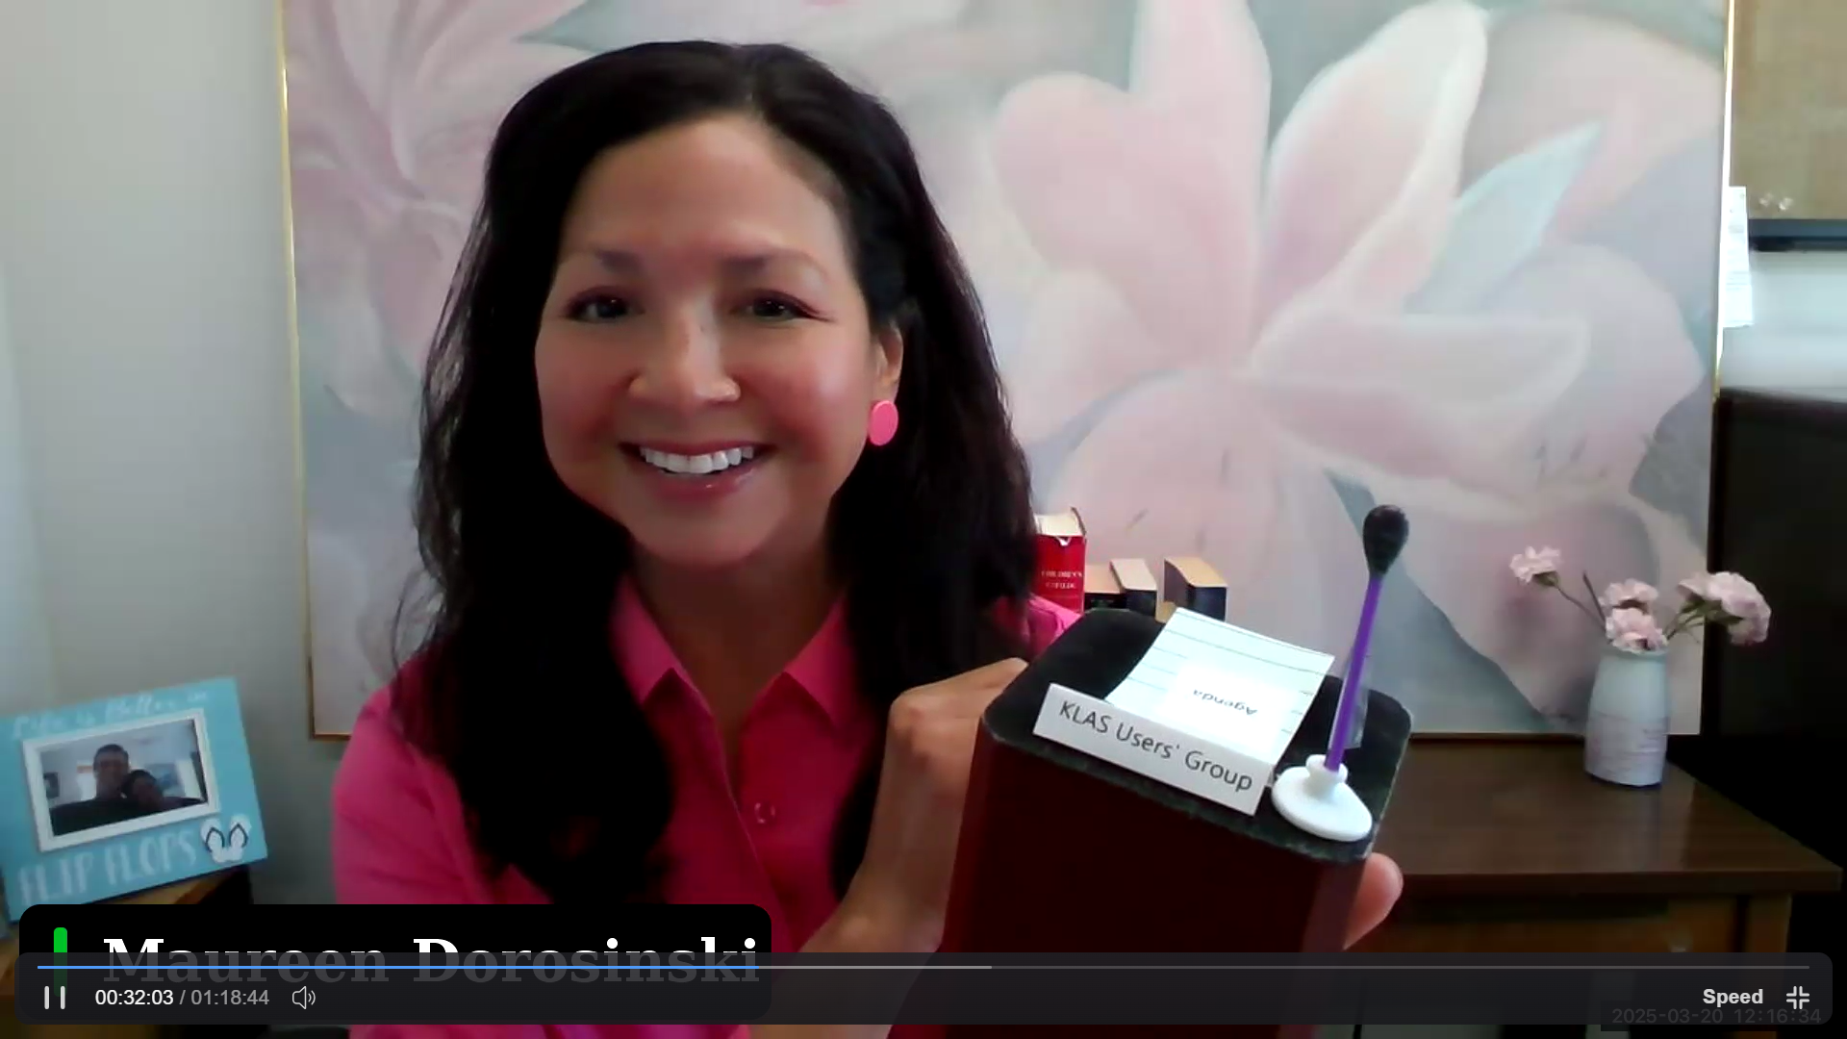

Approval of 2024 Business Meeting Minutes
- Minutes from the 2024 business meeting were posted by Sara Zapotocky on KLASUsers.com after the 2024 conference, and posted again and sent out as part of the 2025 conference materials for members to review.
- Maureen called for any changes or corrections to the minutes, and moved that the group approve them as distributed. James from MA1A seconded. With no objections, motion approved.

Committee Reports
- Logistics Committee: Maureen Dorosinski
  - Maureen recognized Andrea Callicut, Katy Patrick, Lee Anne Hooley, Judy Grey, Debra Martin, Josh Easter, Sam Burkett, and Sarah Smedley, for all the work they did on the Logistics Committee. Their hard work helped make the conference a great success. The next hybrid conference is set for 2027 in Worcester, MA. Anyone is welcome to join the logistics committee, and be part of the planning team!
  - To get a sense of what they plan: for the full conference they choose the venue, the hotel, music for the reception, even attendee gifts.
- Program Committee: Jesse McGarity
  - Jesse is the Technical Operations Specialist with the Accessible Resources and Services Library in Virginia Beach (VA1I). The program committee planned out the conference, but also serves to plan monthly learning sessions as well. If anyone has suggestions for a program or would be interested in joining the committee, feel free to contact her, or Drea or Katy. Like the Logistics Committee, this committee is also open for new members.
  - The Program Committee meets once a month, though months leading up to a full conference, the group may meet twice a month.
- KLAS Development Advisory Committee (KDAC): Drea Callicutt
  - KDAC meets once a month, typically running for about 90 minutes. The group includes representatives from all the market segments of libraries. When a member goes off the committee, a rep from a similar type of library should replace them. An announcement will be made for volunteers for this committee.
  - This is an active group that meets with Drea, Katy, and Kyle, and members have direct communication with Keystone developers. Members of this committee may act as intermediaries between staff and Keystone developers, bringing them your ideas and relaying ideas from Keystone back.
  - Any ideas/suggestions for KLAS that people would like to see developed, can be sent to this committee. Suggestions can also be posted to the KLASUsers Forum; posts are regularly monitored.
Old Business
- Bylaw Updates
  - Proposed updates were posted to klasusers.com. Maureen read the proposals to the group, which consisted mainly of typo corrections and clarifications.
  - For the future, a proposed line to be added to the Bylaws was stated: “Minor revisions, like the correction of typos, misspellings, or grammatical errors, do not require the approval of the membership”.
  - Membership was asked if any other edits should be brought to attention. None being declared, Maureen moved for a vote to approve this new line to the Bylaws. Lee Anne Hooley from MA1B seconded the move to vote, at which time members in person and viewing online were given an opportunity to vote against or in favor. With all votes in favor and no votes against, the new draft for the Bylaws has been approved. The revised copy will be posted to klasusers.com
New Business
- Elections- Vice President and Secretary
  - After reading each position’s description and relaying how an enrollment committee across the network met to review nominees, Maureen announced the two nominees for each role and they were given an opportunity to address the group.
  - For Vice President, James Gleason from Perkins Library in MA was the nominee (and this day happened to be his 19th work-a-versary at Perkins!)
  - AnnaMarie Theiss, from the Alabama Resource Center for the Blind, was nominated for KLAS secretary.
  - After a call for any other nominees in person or online conceded no additional candidates, Maureen moved to close nominations and Jesse from VA1A seconded.
  - Per the Bylaws, since there was only one nominee for each position, a single determining vote was made at the meeting, without taking it to an online vote. Maureen moved to conduct a single vote for both candidates and Josh from SD1A seconded.
  - With all votes yes, James and AnnaMarie will assume the roles in August 2025.
Announcements
- Drea announced that there will be a mini-conference in 2026, free and online, and potentially in May (TBD). 2027’s full conference is set for Worcester, MA, details as far as venue and lodging are in the works.
- If any state has interest in hosting the 2029 full conference, Drea has a planning guide that provides information on what would be needed to run it. Please feel free to reach out to Drea or the programming committee for questions.
Adjournment
There being no other business, Maureen made a motion that the business meeting be adjourned. It was seconded by Josh, SD1A. There being unanimous approval, the 2025 Business Meeting was adjourned at 12:57 PM ET.

Submitted by Sara Zapotocky, Secretary

