How to Query for Juvenile Patrons  
without a Parental Acknowledgement

# Process overview

To get a list of Juvenile Patrons that do not yet have a Parental Acknowledgement as required by NLS, you will need to use Merge Queries.

1. Query A: all Active Juvenile Patrons.
2. Query B: Active Juvenile Patrons that ***do*** have a Parental Acknowledgement property.
3. Use merge queries to find “In A not B.”

# Query A: all Active Juvenile Patrons

1. In the Patron module, open Query using the  toolbar icon, Queries menu, or Ctrl-q.
2. On the Quick Search tab, set:
   * Patron Type | Begins | P
   * Main Status | Equals | A
   * Birth Date | Is Between | 01/01/2007 | 01/01/2025   
     (Or with the dates adjusted to be [today minus 18 years] | [today])

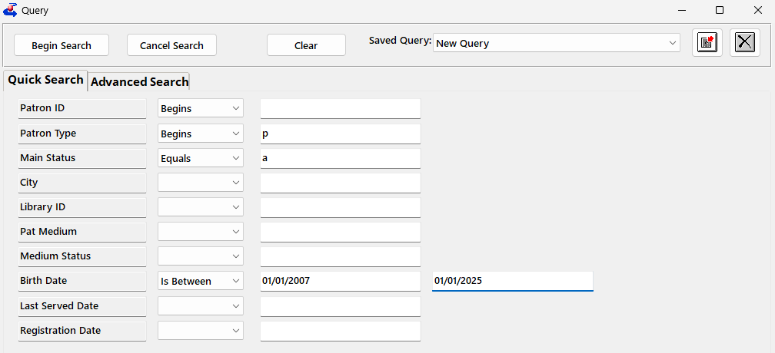

1. *(Optional)* Save the query for later using the Save Query Parameters button right after the Saved Queries field. 
   * Mark the **Create an ID For Me** checkbox.
   * Enter “Juvenile Patrons” as the **Saved Options Name**.
   * Enter “Update Birth Date range as needed” as the **Description**.
   * Select Ok. The Query options will be added to the Saved Queries list.
2. Use the Begin Search button. The Query Results will open.
3. Double-click any result to open the Query Set.

# Query B: …that have a Parental Acknowledgement property

1. Open Query ( toolbar icon, Queries menu, or Ctrl-q).
2. Select Juvenile Patrons from the **Saved Query** combo-box, or re-add the Quick Search criteria above.
3. Add these additional fields on the Advanced Search tab (Alt-2):
   * Preference | Type | Equals | ParentalAck
   * Preference | Code | In | Yes,No   
     (to instead exclude only the Yes acknowledgements, use Equals | Yes instead)

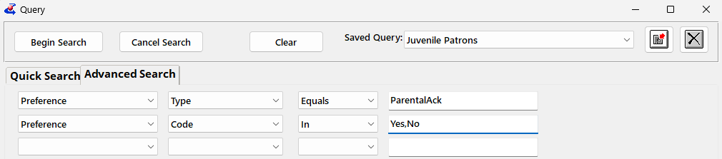

1. (Optional) Save the new Query using Save Query Parameters. 
   * Switch the Radio button to **Create New**.
   * Mark the **Create an ID For Me** checkbox.
   * Name it “Juveniles With Acknowledgement” or similar.
   * Select Ok.
2. Begin Search.
3. From the Results page, double-click any result to open the Query Set.

# Merge to find “In A not B”

1. From the Queries menu, select Merge Queries.
2. Select **Query A** and **Query B** from your recent queries list.
3. Set the **Merge** to In A Not B.
4. The combined results will be listed on screen.
   * To save the list: use Export to Excel (Alt-Ctrl-x) from the Merge Query screen to open the combined results (all Active Juvenile Patrons that *do not* have the Parental Acknowledgement) in Excel.   
     Increase the Maximum to at least the count of results from the Merged Query. Select All Fields if you do not have email displayed on screen and want it in your results; otherwise, select Visible Fields.
   * To print mailing labels: double-click any result to open the combined Query Set. Use the Functions menu to select Print Labels, and set it to print for **Entire Query Set**.