Add Un-Barcoded Items

Process Overview
When Items come without a suitable barcode already in place, or if you do not use unique barcodes on your Items (non-copy-specific), the Items should be received into KLAS using the Batch Add Items function.
- Find (Ctrl-f) the Title and set the Volume Count on the Title-Bib tab (Alt-1).
- If this is the first copy of the Title, add a Holding on the Holding tab (Alt-6).
- From the Functions menu, select Batch Add Items. Enter the KLAS ID and Quantity, then Add Items.

Set Volume Count
- In the Catalog module, Find (Ctrl-f) the Title you want to add Items for.
- Check that the # Volumes and Copies Identical checkbox on the Title-Bib tab (Alt-1) are set as desired.

Add a Holding
The first time you add inventory for a Title, you will need to add at least one Holding for that copy to go into. The Holding and Shelf determine the Item’s Circulation Policy.
- On the Holdings tab (Alt-6), add a new Holding using the Add Record button (Ctrl-n).
- The Branch will default to your log-in library.
- Enter the default Shelf. This will usually be “Shelf,” but you may have a different shelf to use for local titles or items with a custom loan policy (such as “Cartridge” for duplication cartridges).
- If desired, set a specific Loan Code. If none is selected, the default circulation policies for the title’s Library, Shelf, and Medium will be used.
- Save the new holding. (Ctrl-s)

Add Items
- From the Functions menu, select Batch Add Items.
- The Batch Add Items screen will open. Enter the KLAS ID or use the Lookup button to select it. Once you Tab or click into another field, the Title will be displayed.
  - Confirm that you are adding Copies to the correct Title.
  - If you are adding a partial copy, un-mark the Add All Volumes checkbox and select the Enumeration to add. Otherwise, leave this box marked.
  - Enter the Quantity of copies to add for this Title.
  - If needed, update the Home Shelf, set a Temp Shelf, and/or select the Acquisition Method.
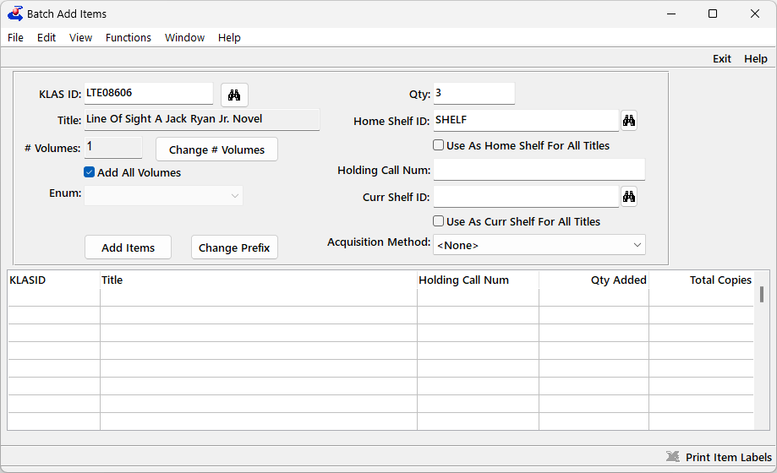
- Once all fields are set appropriately, use the Add Items button.
All Items and Copies will be assigned Barcodes automatically, added to the Catalog record, and will be Available for circulation right away.
- If desired, use Print Item Labels from the toolbar or the Function menu to print the barcode labels.
  - Set the Label Type to Item Labels, Barcode Labels, or Consumable Labels as appropriate.
  - Select the Stock Name and Printer. If a new Stock type is needed, contact Customer Support.
  - Use the Print button.

