How to Add a Local Title

Process overview
When adding a non-NLS title, the following information is required:
- A Unique KLAS ID.
- Title Status (such as In Process or Active).
- Basic bibliographic info, particularly Title, Reading Level, and Language.
- A Holding record for physical items, such as Print Braille, Large Print, or Descriptive Videos.

Step One – Add a Record for the New Title
- Open the Catalogue module from the KLAS Desktop. This will open the “Cataloging Maintenance” window.
- Use the Add Record button. (Ctrl-n)
- KLAS will prompt you to choose a Record Type. Choose Monograph.
- Fill in the KLAS ID prefix, entering only the correct prefix for that medium. KLAS will automatically fill in the rest of the ID based on your library’s sequence settings.
OR, if using user-generated IDs, enter the full, unique KLAS ID.
- Set the Title Status to:
  - In Process if the recording/copy is not yet finished, and/or if not all the needed cataloging is added (such as Audience Notes re: sex, violence, and strong language).
  - Active if the title record and recording/inventory are ready for circulation.
- If the Title Status is In Process and the title should not be visible on the OPAC yet, check the OPAC Suppress box.
- Enter the Title.
- Select the Medium.
KLAS now has all the information it needs to create the record, but the more information you fill in, and the more accurate and consistent it is, the easier it will be for you and your patrons to find the title you are searching for. Try to always fill in as much information as you can for each title.
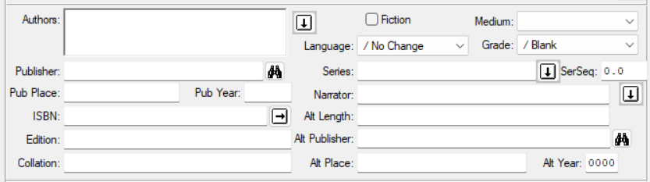
- Enter the Bibliographic information, including: Author, Publisher, Pub Year, Fiction yes/no, Language, Grade, Series, and Annotation.
Use the Select Headings (down arrow) or Lookup (binoculars) buttons where available to ensure consistent data and formatting. See next section for more info on using Select Headings.
- Enter the recording / alternate format information, including the Narrator, Alt Length (00 hours, 00 minutes), the Alt Publisher (who put the title into this specific format, such as your library for a local recording), and the Alt Year (the year recorded / transcribed). When adding the Narrator use Select Headings (down arrow).
  - The # Volumes is the number of physical items which make up a complete copy, such as '6' for a six-volume braille title. If volumes of a copy are identical and are thus interchangeable with one another, check the Copies Identical box.
  - The Consumable checkbox is for items that patrons need not return.
- Enter local Subjects using the Select Headings button.
  - If you know the exact Subject or Subject Code you wish to add, you may type it in instead. Separate multiple subjects with a semi-colon.
  - Otherwise, use the Select Headings button to choose from the list of available subjects. (See next section.)
- Save the new title record. (Ctrl-s)
If desired, full Subject cataloging or other additions can be entered on the MARC tab (Alt-4).
If the Title was given a Status that displays on your WebOPAC (and the OPAC Suppress box was not checked), it will be indexed and displayed in the OPAC almost immediately.

Using Select Headings
It is easy to enter an author’s name different ways (Rowling, Joanne; Rowling, J.K.; or Rowling, JK), so KLAS uses “headings” to help you make sure it is always entered the same. This means you will not need to search multiple ways to find all titles by a certain author. Narrator, Series, and Subjects also use headings for the same reasons.
- Beside any field that uses headings, use the Add Heading button.
- The Select Headings window will open, with a list of all available headings for that field on the left, and a list of selected headings on the right.
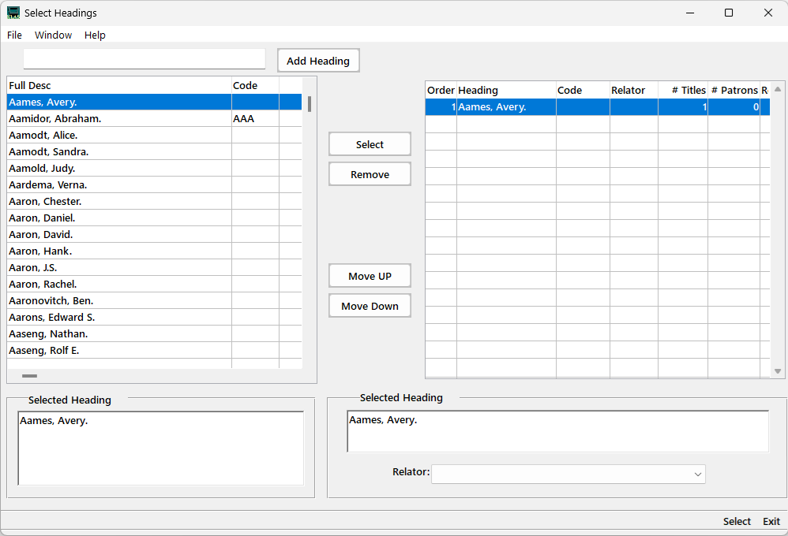
- Scroll through and select the correct heading. You can search the list by entering a term in the top field and pressing Tab.
Note: If you are certain that the author you need is not listed, type their name into the top field exactly as it should appear and use Add Heading. Do not add new subject or series heading using this window.
- Use the Select button between the two columns to add the highlighted heading to the list on the right. Repeat for as many headings as apply to that title.
- If appropriate, add Relator or Series Sequence information for the heading selected in the column on the right.
- When all appropriate headings have been selected, use the Select button at the bottom of the window (or Alt-s) to add them to the record.
- Save the record (Ctrl-s) before you open the same Select Headings window again, otherwise your selections will be lost.

Step Two – Add a Holding
The Holding record controls the circulation policies for physical titles; if you need to set additional policies, contact Customer Support for assistance setting up a Shelf or Loan Code.
For Duplication- or Download-only titles, a Holding is not necessary; instead, circulation policies will be set by the ePackage (which is generated automatically along with the eDoc).
- On the Holdings tab (Alt-6), add a new Holding using the Add Record button (Ctrl-n).
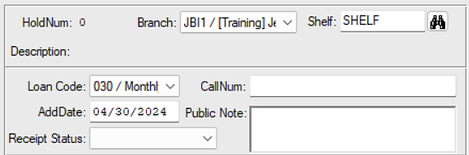
- The Branch will default to your library.
- Enter the default Shelf. This will usually be “Shelf,” but you may have a different shelf to use for local titles with a custom loan policy.
- If desired, set a specific Loan Code. If none is selected, the default circulation policies for the title’s Library, Shelf, and Medium will be used.
- Save the new holding. (Ctrl-s)
The Title record is now ready for you to upload files and allow the eDocs to be created (See: Upload Local Titles), and/or receive Copies & Items (See: Add Barcoded Items for copy-specific or Add Un-Barcoded Items for non-copy-specific items) for physical circulation.

