How to Upload Local Titles

For Scribe

# Process overview

For duplication to succeed, you need three parts: a file on your Scribe, a record in KLAS, and an eDoc that connects the two.

We provide books.klas.com as a standardized depository for local files, allowing you to distribute locally recorded books, serials, and instructional files to all of your Scribe units at once, and ensuring that these files will not be lost if your Scribe has a memory failure.

You will need to use an FTP Client to upload the files. WinSCP and FileZilla are popular choices, but any FTP Client that is provided or allowed by your parent agency is fine.

1. Create a catalog record in KLAS for the local title, and set the appropriate Medium and Language.
2. Compile the recording in DTB format, and save the DTB files as a zipped folder using the KLAS ID as the filename (for example, DBC01234.zip). This must be an exact match to allow KLAS to connect the record and the file with an eDoc.

For Serials, the filename must be the Issue Name. For more information about local serials, see LocalSerials-Scribe or the full Serials Manual.

1. In your FTP Client, add a site/profile (first time connecting) or select the books.klas.com profile (subsequent connections).

When adding the site/profile, use these settings:

* + **Protocol:** SFTP
  + **Host:** sftp://books.klas.com
  + **Port:** 12360
  + **User:** Library ID (Ex: nc1a)
  + **Password:** provided by Keystone; you may also be prompted to enter this when logging in

Example set-up (your program may look different):

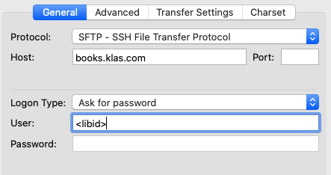

1. Once connected to books.klas.com, drag and drop your .zip file(s) into the appropriate directory. (Your FTP Client may also have keyboard command options for uploading the files without using a mouse.)

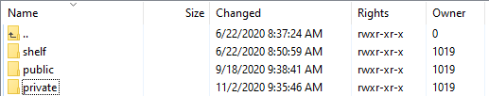

* The Public directory is for files that can be downloaded by non-authenticated users.
* The Private directory is for files that should only be downloaded by logged-in users.
* The Shelf directory is for files to be shared with other libraries via the SHELF project.

**Note:** Regardless of directory, your serials are *only* displayed on the WebOPAC at your request.

For Serials, place the .zip file into a subfolder matching the Serial ID, for example:

* private\SDS-ABC4\Winter_2024.zip

1. Once the files are uploaded to books, they will be available for duplication the following day. In the meantime:

* Your Scribe(s) will download new files overnight, ensuring that these titles will be available in their local storage for duplication the following day.
* A process will run overnight to pair up the files to the matching catalog records in KLAS, and automatically create the eDocs recording this match.