Do You Want to Build a Booklist?
  - It doesn’t have to be a booklist …
How to use Mail Merge to turn a KLAS Export into a formatted booklist or other document.
- Step 1: Create a Query Set of books that will form your booklist
- Step 2: Export the Query Set
- Step 3: Begin the Mail Merge
- Step 4: Select the information to include
- Step 5: Make it look nice
- Step 6: Create the final document
- Step 7: Make Another List!

Step 1: Create a Query Set of books that will form your booklist
This could be a standard query set generated from your input criteria of subjects, dates, languages, exclusions, etc. Or, if you have a specific list of books you’ve already created, you can copy the KLASIDs into a .txt file and use Import Query Set. You can even use Book Search if the book search gives you the criteria you need. You just need a table of results you can export from KLAS into an Excel document.
For this example, I’ll be using this query: Klas ID begins DBC; Subject begins New Mexico; Narrator Matches La Farge
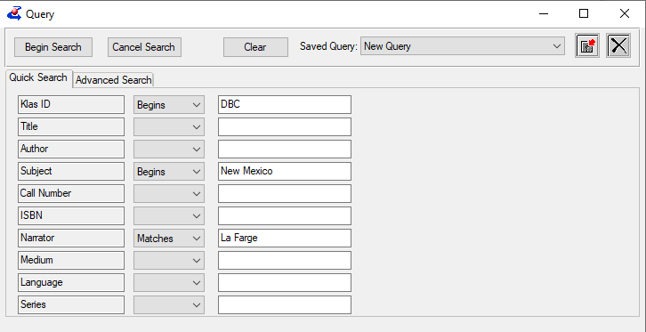

Step 2: Export the Query Set
From the Search Results window after you’ve created your query or search, select the Export button in the bottom right, or press Alt-Ctrl-X.
A Transfer to Excel popup will open; select All Fields. Excel should open with all the results of your query. Save this spreadsheet somewhere you can find it, with a meaningful name, and then close Excel.
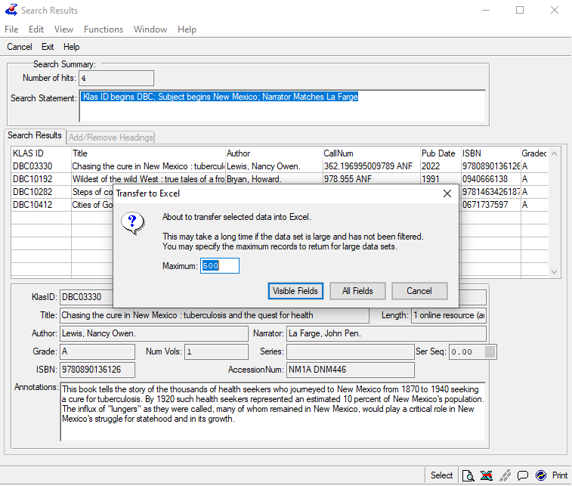

Step 3: Begin the Mail Merge
N.B. Next steps may vary slightly based on your version of Word.
Open Word and navigate to the Mailings tab. To the right of Start Mail Merge, go to Select Recipients, and click Use an Existing List…
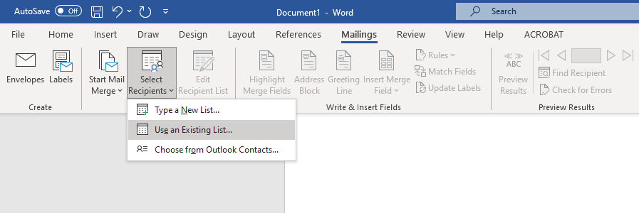
A file browser will open. Find and select the Excel document you saved in step 2. Word will prompt you to Select Table. Select the only option: RowObject$ and hit OK. Nothing obvious will happen, but the data will have been pulled into Word to work with.

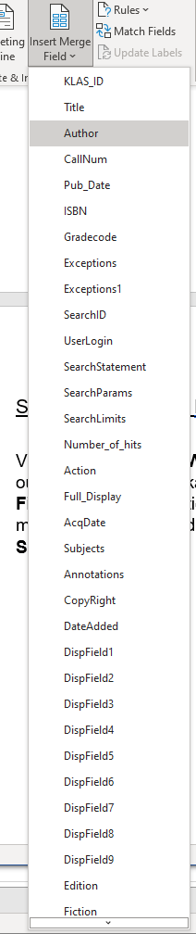
Step 4: Select the information to include
Various options in the Write & Insert Fields area that were previously greyed out are now active. We will primarily be using Insert Merge Field. Clicking this button will open a large dropdown menu of options matching the column headings from the Excel document selected in Select Recipients. Most of these are self-evident, but you may need to refer back to the Excel document for others.
When you select one of these options from the dropdown, it will insert a placeholder into your document. For instance, selecting Title will insert «Title» into your document. You can insert as many or as few of these as you would like. An example setup would be something like:
«KLAS_ID» «Title» «Author»
«Annotations»
Once you have all the fields you’d like to display for each book, click Rules from Write & Insert Fields and select Next Record.
This «Next Record» is how we include each of the different books from the Export in a single document. It must appear at the end of the block of fields you’d like to show up for each book.
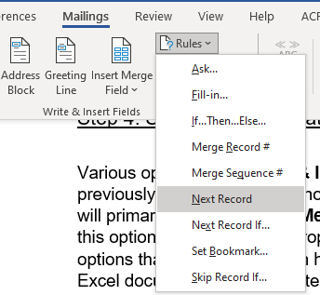

Step 5: Make it look nice
You can apply formatting to the fields inserted in the previous step that will be transferred to whatever information is pulled from the Excel document. You can also add whatever text, markup, or other elements you’d like.
For instance, you might set up something like:

«Title» - «KLAS_ID»
By: «Author» «Pub_Date»
«Subjects»
«Annotations»«Next Record»
To see what your book list will look like, press the Preview Results button at any time to switch between the code and the actual booklist.
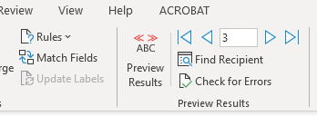
When you have something you’re happy with, Copy & Paste your block of text as many times as you want. This will determine the maximum number of books in your list. Make sure you have the Next Record rule included at the end of each block or Word will just show the same book over and over.
If you want a numbered list, you can do that manually or use the numbered list feature from the Paragraph section of the Home tab.

Step 6: Create the final document
You have a few options for creating the final product, based on the format you want.
- If you want a printed document, you can print any time with Preview Results turned on. The document will print exactly as it is displayed.
- If you want to save a Word Document, select Finish & Merge, select Edit Individual Documents, highlight Current Record and the select Ok.
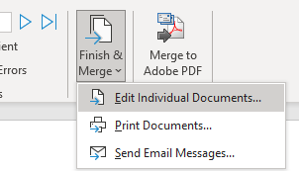
- If you want a different electronic document format, you can select Merge to Adobe PDF or, with Preview Results turned on, use File > Export to save as a PDF or other file type (such as html).
So long as your template used accessible formatting and markup, your merged output will as well.

Step 7: Make Another List!
Because KLAS Query and Book Search exports have a consistent layout, you can use your same template for any results list you want to make a booklist out of! Once you’ve exported your next list of books, use Select Recipients from step 3 to import the new excel file into your existing Word document. The new data should transfer in seamlessly, allowing you to Preview or Finish and Merge to insert the new data into your existing formatting, with no edits needed.

