How to Merge Patron Records

Overview
The Merge Patron tool automatically copies information from one patron record to another.
- Open the Merge Patrons tool and fill in Patron IDs and new status for merged patron.
- Click Merge Patrons to process the changes.
- Review the merged records and update BARD and webOPAC information as needed.
- If desired, the merged record can be deleted.

Step One – Open Merge Patrons and fill in Patron IDs and new status
- In the Patron Module, open Merge Patrons from the Tools menu.
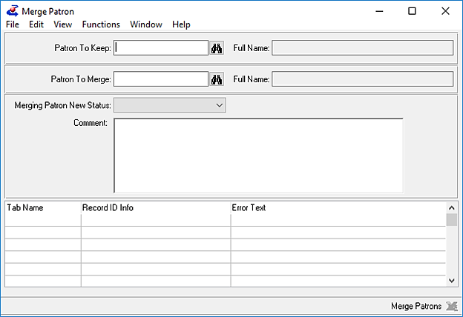
  - Enter the newer Patron ID into the Patron to Keep field
  - Enter the older Patron ID into the Patron to Merge field
  - Check the Full Name fields to confirm that the correct accounts were selected
- Set the desired status for the older Patron ID after the merge.
We recommend ‘Merged,’ ‘Withdrawn,’ or any status that will clearly mark the older record as no longer needed, but still allow you to review the merge results before deleting the older record.

Step Two – Process the changes.
- Click the Merge Patrons button to process the changes. Things that may be copied, depending on your library’s settings, are:
  - Assigned and Out titles (Has-Nows)
  - Circulation History (Has-Hads)
  - Requests / Material Requests
  - Reserves
  - Blocks
  - Fees/Fines
  - Contact Tab (including historical contacts)
To update the control file that determines which of these are and are not copied, contact Keystone Support.
- When the process is complete, the Patron information will be cleared from the Merge Patron window.

Step Three – Review the merged records
- Copy over any information that is still needed but was not automatically imported, such as Comments or Subscriptions.
- If the patron has a BARD account, update it with the new Barcode (“CMLS ID”).
- If they are a webOPAC user, you will need to set a new password for them. Make sure the patron is notified of their new Patron ID and password.
If they are a WebOrder user, you will need to move their User ID to the new record.

Step Four – Delete the Merged Record
- When you have confirmed that you have everything you need, you may choose to delete the old record.

