  - How to Build Your Own

Summer Reading Queries

Process overview
Queries are your best tool for generating a list of records (such as patrons or books) matching certain criteria. Once you've successfully queried for a patron list, you can use it to print mailing labels or export it for a list of the patrons’ email or mailing addresses.
Here are search criteria that may be helpful for your Summer Reading Programs or other programs you wish to promote. Pick and choose just the lines that help narrow in on just the records you wish to target.
Once you’ve assembled a query that meets your needs, don’t forget that you can Save the Query Parameters to use again later!

Outline
- Patron Queries
  - Quick Search tab
  - Advanced Search tab
- Catalogue Queries

One – Patron Queries

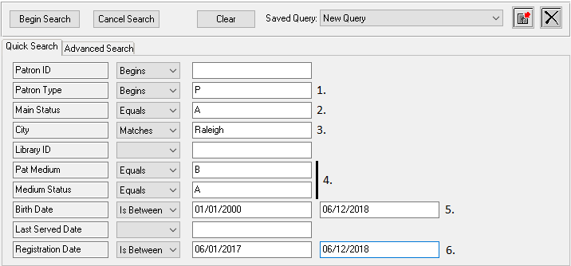
Quick Search tab
- This will limit results to records with patron types including PA – Individual Patron, PJ – Juvenile Patron, and PY – Young Adult Patron. Institutional patron types (such as IN – Nursing Home) would be excluded.
If you only want to include a single patron type, such as PA, you would instead set the criteria to be “Patron Type : Equals : PA” (or whatever code you are targeting).
- This limits results to records with a Main Status of Active, so that suspended or deceased patrons will not be included.
- If you want to limit results by City, do so here. The “Matches” search type instructs KLAS to look for the criteria anywhere in that field. For example, this search would include “North Raleigh” in the results. To limit by County instead, see the Advanced Search tab.
Note: this is looking at the city in the patrons’ current shipping address, as shown in the header of the Patron Module.
- If you want to limit results to patrons active in a certain Medium, use these two lines together. Set the “Pat Medium : Equals” line to the desired code (such as B for Braille or DB for Digital Books) as shown in the Medium combo-box on the Profile tab.
- To limit results by the patron’s age, you need to tell KLAS the date range to look in. Setting the “Is Between” search type will load the second box for the end of the date range. This example will return all patrons born in the past 18 years—in other words, all juvenile patrons.
- Registration Date is useful for generating a list of patrons who were entered into your system recently, such as new patron since the previous Summer Reading Program.
Advanced Search tab
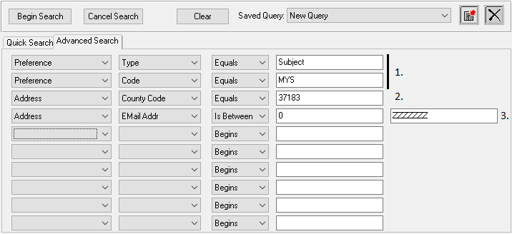
The Advanced Search tab can be used in addition to the Quick Search—criteria on both tabs will be considered. You will need to fill out all fields for the row you are using.
The first two combo-boxes tell KLAS where to look for the information, the next one sets the search type just like on the Quick Search.
- To get a list of patrons with a certain preference code, you will need to include the Preference Type on one line, and either the Code or the Value on the next.
Some libraries use a preference code to track participants in their Summer Reading Program, which makes it easy to query. If you want more information about tracking your participants this way, email ks7.
- To limit results by county, you will need to determine the unique County Code. From the Contact tab, update any address and use the Lookup button next to the County field. The Code for each county will be listed.
- To limit the results to only patrons with an email address on file, search for patrons with an email between zero and ZZZZZZZ. This range covers all email addresses.

Two – Catalogue Queries
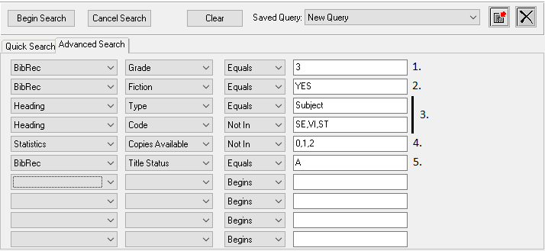
- To limit the search to a certain Grade Range, look at the grade combo-box on the Title-Bib screen for the correct code.
- KLAS “sees” the Fiction check-box as YES when it is checked, and NO when it is un-checked.
- To exclude certain Subject Codes, such as those for strong language and violence, use two lines to specify that you are looking for subject headings by code. Separate each code with a comma, no space.
If you want to limit the search to certain codes instead of excluding them, use an “In” search instead.
- You can make sure that you have Copies Available by excluding results with only 0, 1, or 2 available copies. This means that all results will have 3 or more copies available. (You can add more numbers to the list as needed.)
- To make sure the title is in Active status, limit the search by Title Status. If you want Download Only results to be included as well, you could search for “Title Status : In : A,DO” instead.

